Student Name | G. Manasa
Student Registration Number | 241U1R3007 | Class &Section: CSE(DS)
Study Level: UG/PG | UG | Year &Term: I & II
Subject Name | Probability & statistics

Name of the Assessment | Reflective Journal -7
Date of Submission | 24/08/2025

Reflective Journal Template
Journal Entry Guidelines | Description
1. Experience (Class Content) | Briefly describe the topics or concepts discussed during the class.
2. Feelings (Emotional Reactions) | Share your emotional reactions and thoughts during the class.  How did you feel while learning this theory?  Did the class evoke specific emotions or questions?
3. Learning (Key Insights) | Reflect on what you learned from the class.  Highlight the key insights or fundamental concepts you gained from the class.
4. Application (Practical Use) | Describe how you plan to apply the theory you've learned in real-life situations or in your academic/career endeavours.  Explain the practical utility of this theory.

Sample Journal Entry

Date | 24-08-2024
Journal Entry Topic | Large samples  Tests Concerning a Single Mean, Tests on Two Means
1. Experience (Class Content) | In this module we learned about large sample if the sample size is grater than or equal to 30 then the sample is known as large sample and next we learned about procedure for testing of hypothesis there are major steps in testing hypothesis  Step1: Null Hypothesis($h_{0}$)  step2: Alternative hypothesis${(H}_{1}$)  step3: level of significance($α$)  step4: test statistics  step5: conclusion  And next we learned about test of significance of a single mean or z test for single mean x1,x2,..xn be a random sample size n(n>30) has the sample mean x drawn from a normal population with mean $μ$ and variance $σ^{2}$ and next we learned about test for equality of two means or z test for two means x1,x2,..xn be a random sample size n from a normal population with mean µ2 and variance$σ^{2}$ . While learning, I practiced problems where I had to test whether a single sample mean is equal to the population mean, and also cases where I compared two sample means.
2.Feelings (Emotional Reactions) | At first, I thought statistics was only about numbers and formulas, and that made me feel worried. But slowly, I came to know that it is actually a tool that helps in making decisions, and this made me curious and interested. When I solved practice problems and got the right answers, I felt happy and confident. Sometimes I still felt a little scared while using the formula for standard error, but with more practice, that fear started to go away. In the end, I felt motivated because I understood that these tests are not only useful for studies but also in real life, like in business, medicine, and research.
3. Learning (Key Insights) | 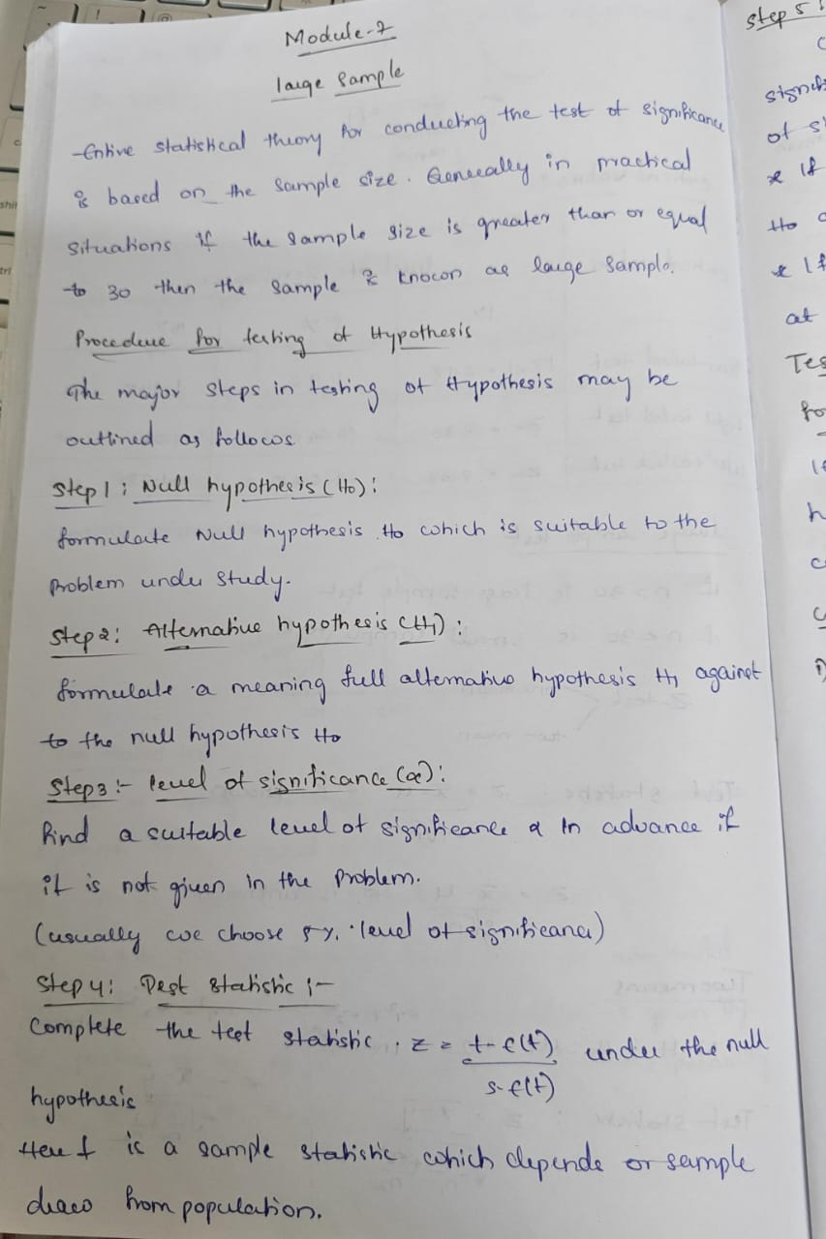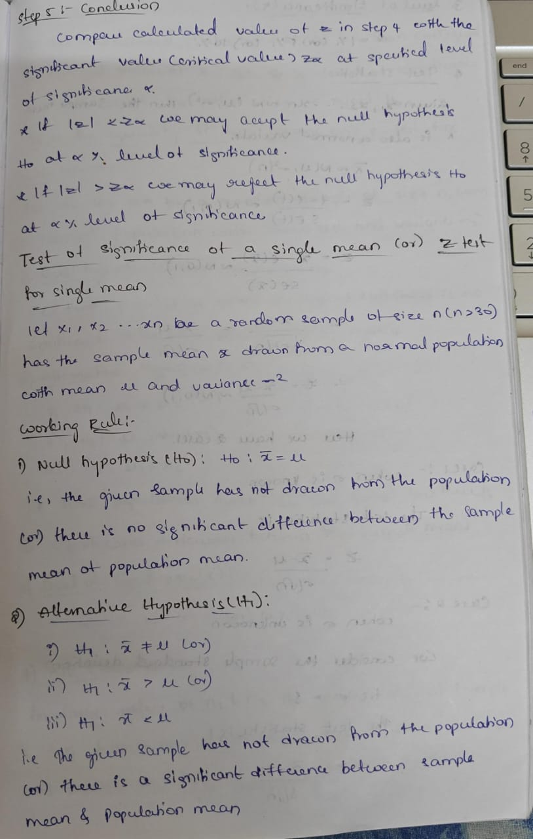  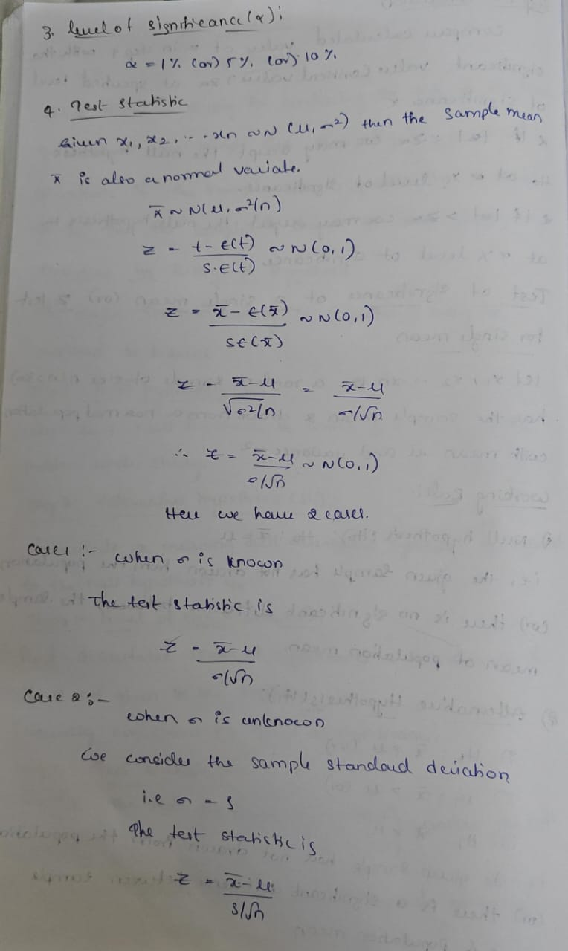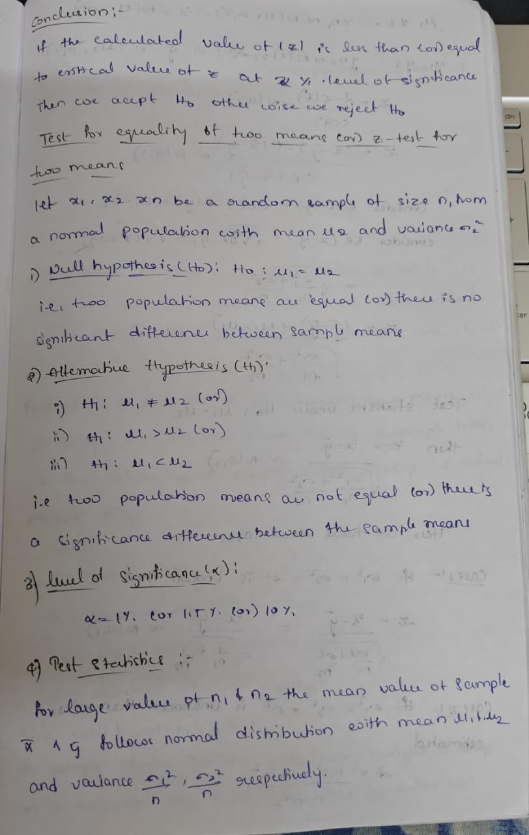  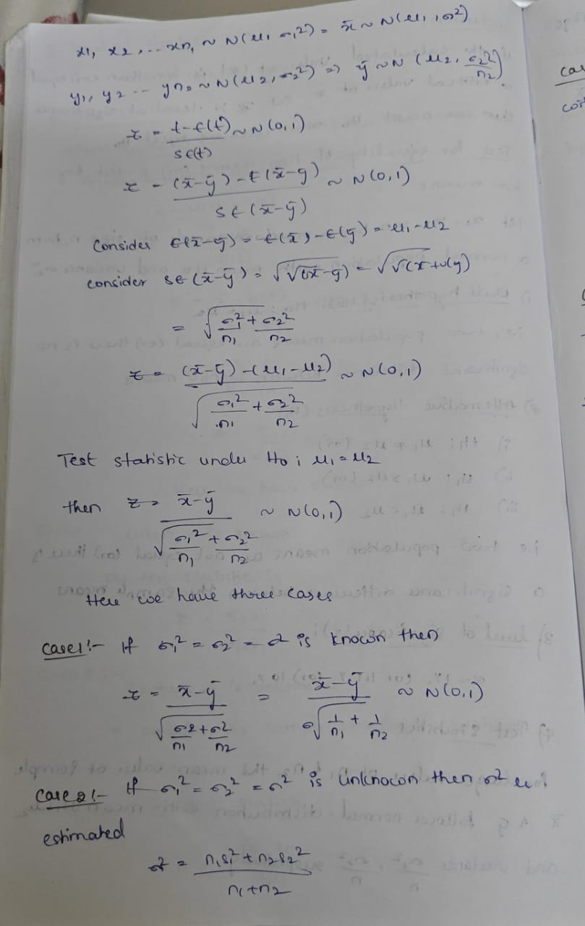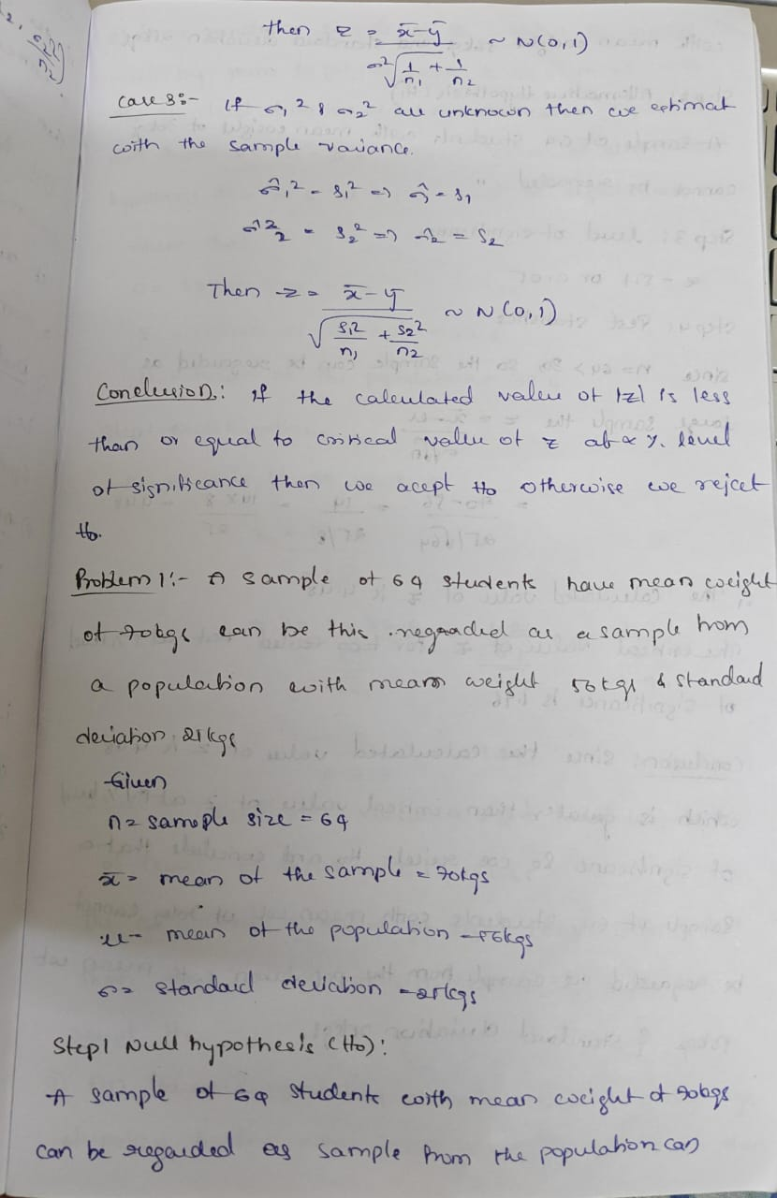  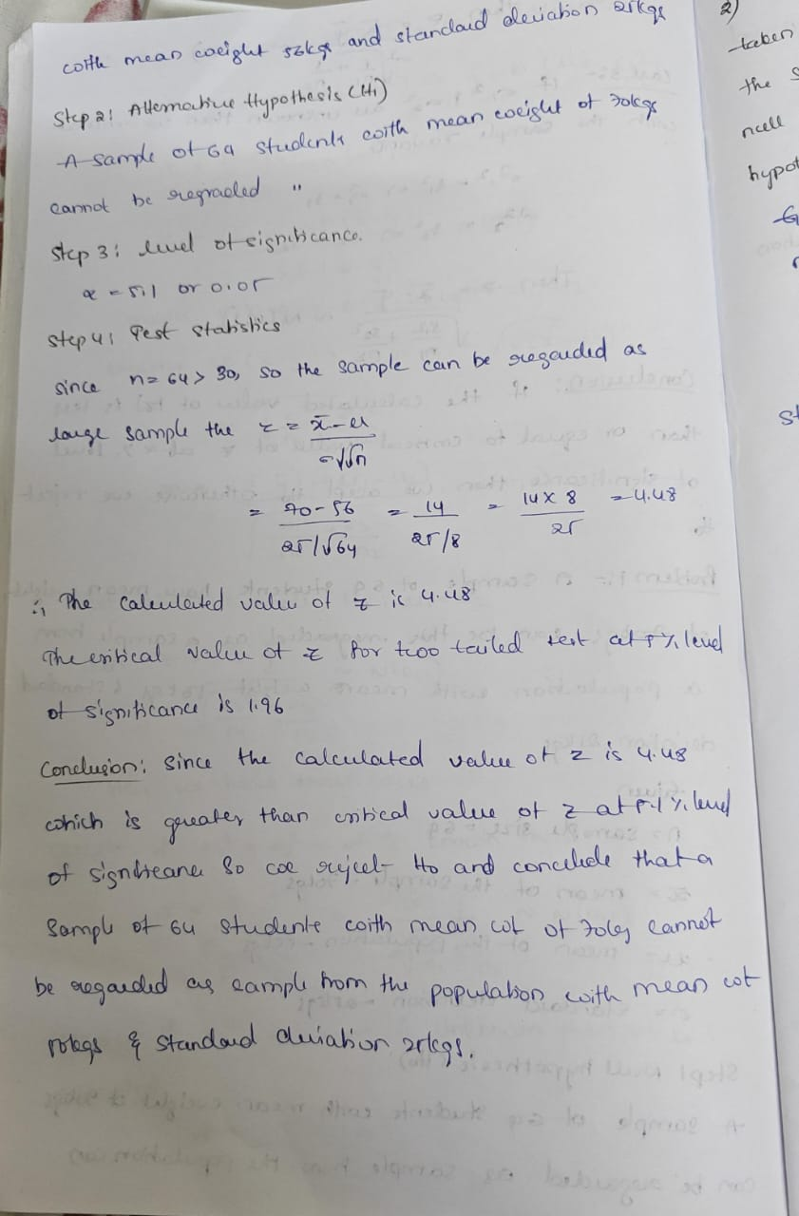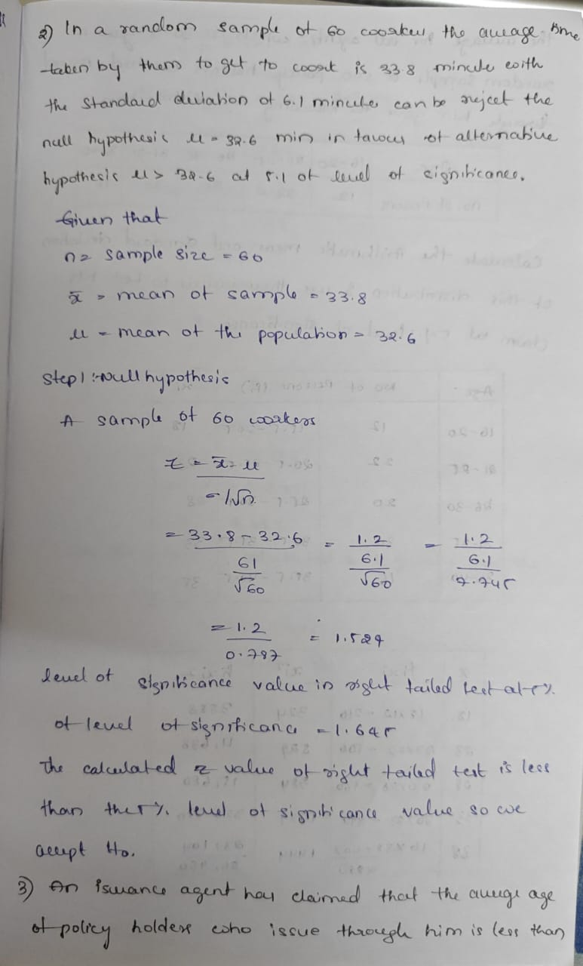  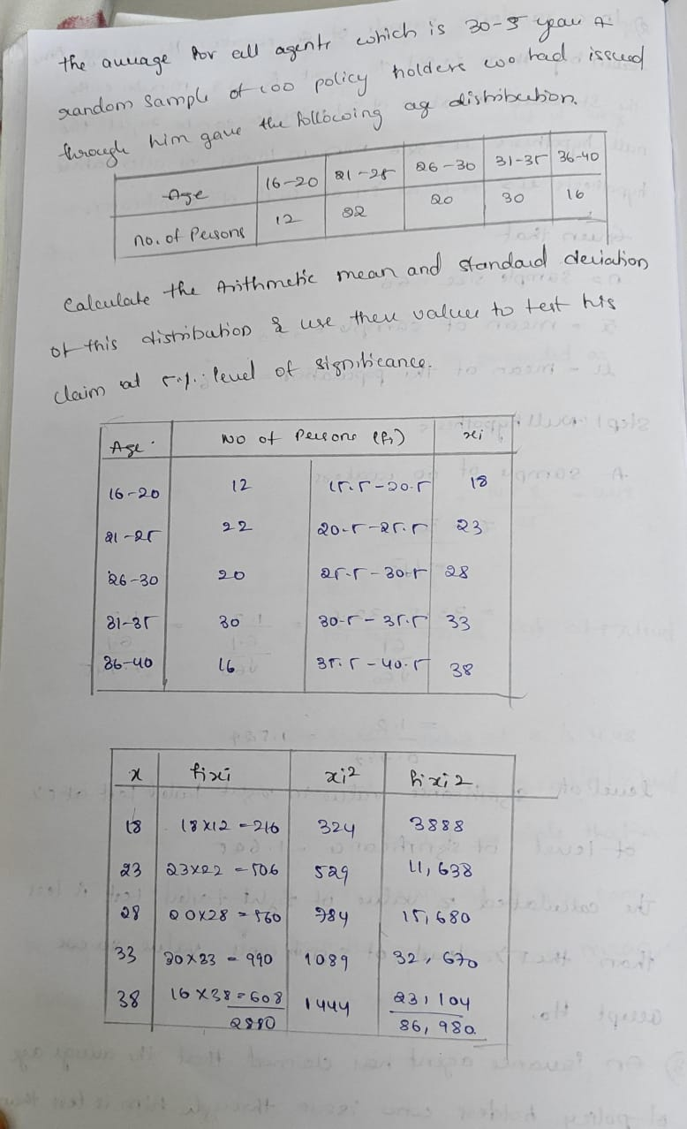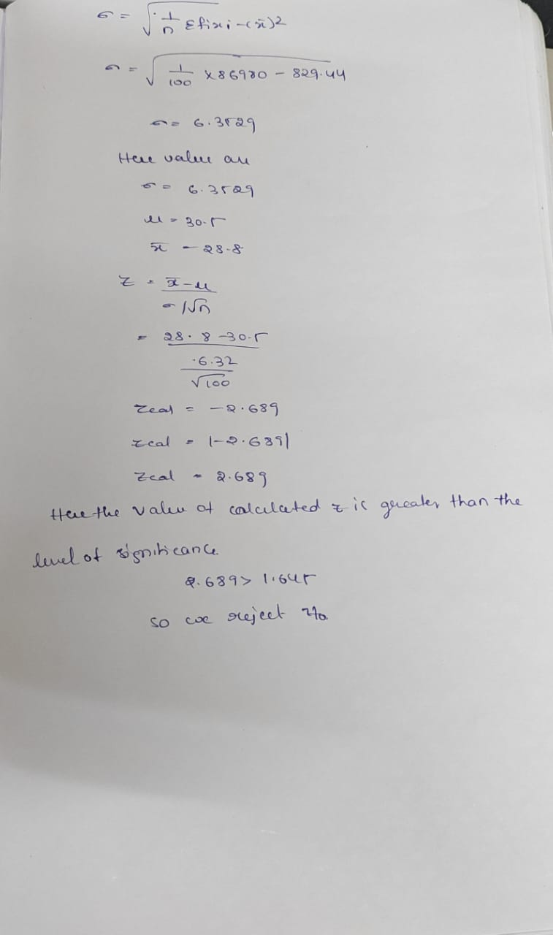
4. Application (Practical Use) | Applications for Large Sample Tests for a Single Mean  - Quality Control:  A beverage company claims its soda cans contain a specific average volume. A large random sample of cans can be tested to see if the actual average volume differs from the claimed amount, concluding whether the filling process is accurate or needs adjustment.  - Product Performance:  An electronics manufacturer sets a target for battery life in a new model of a device. A large sample of devices can be tested to verify if the average battery life meets or deviates from the manufacturer's stated target.  - Medical Research:  A pharmaceutical company developing a new drug wants to know if the average reduction in a specific symptom is significantly different from a known baseline level. A large sample of patients receiving the drug can be compared against the established baseline mean.  Applications for Large Sample Tests for Two Means  - Education:  A researcher wants to compare the effectiveness of two different teaching methods on student performance. They can take large, independent samples of students in two different groups, teach them with Method A and Method B, and then compare the average test scores to see if one method leads to significantly higher scores.  - Marketing Research:  A company tests two different advertisement designs to see which is more effective at generating a higher average customer engagement rate. Large samples of customers are shown each ad, and their engagement is measured. The test determines if there is a statistically significant difference in engagement between the two ads.  - Agriculture:  A farmer wants to know if a new fertilizer formulation increases the average crop yield compared to the standard fertilizer. Two large, independent plots of land are used, with one receiving the new fertilizer and the other the standard. The test then compares the average crop yields from the two plots.
Conclusion | In conclusion, learning about large sample tests (single mean and two means) made me more confident in using statistics in real-life situations. At first, I was nervous and thought it was only about remembering formulas. But later, I realized the method is clear: first write the hypothesis, then calculate, compare, and finally make a conclusion.  This topic helped me understand how to check if differences in data are real or just happen by chance. The best part I learned is that statistics helps us make decisions based on facts, not guesses. Now I feel more interested and encouraged to practice more problems.

